Linux Servers
Classroom Assignment 4 – Disk management
Joni Korpihalkola
Document your commands or take screenshots. Answer questions in english or finnish.

More disks
Add three new 5G disks to your VirtualBox VM. The VM needs to be powered off for this. Boot the VM and check with fdisk that you have three new disks as sdb, sdc and sdd. Create one maximum sized partition to all disks with fdisk.
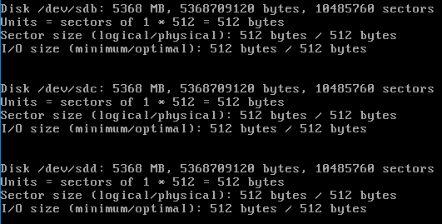

XFS
Create a new XFS filesystem to sdb1. Create a directory called storage to /media. Mount your new XFS partition to this directory permanently using fstab.
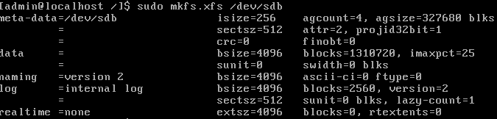
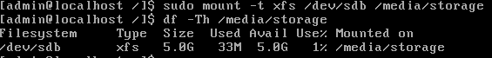

LVM
Create a new LVM PV to sdc1. Create a new LVM volume group called backups using that PV and create a new logical volume (LV) on it with the name everything. What is the correct path to point to this LV now (where in /dev can it be found?)
Create a new xfs filesystem to that LV and mount it to a new directory /media/everything.
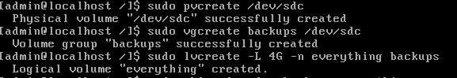
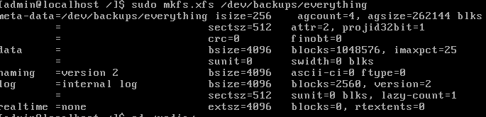

Extending LVM
Use the final disk (sdd1) to extend your volume group and LV. First create a new PV on sdd1, then extend the volume group and logical volume, and finally resize the XFS filesystem. Check that you have more free space with du –sh.
